Second Order Derivative (The Laplacian
Code:
import cv2
import matplotlib.pyplot as plt
image = cv2.imread('cev.jpg', cv2.IMREAD_GRAYSCALE)
laplacian = cv2.Laplacian(image, cv2.CV_64F, ksize=3)
laplacian = cv2.convertScaleAbs(laplacian)
plt.figure(figsize=(12, 6))
plt.subplot(1, 2, 1)
plt.title("Original Image")
plt.imshow(image, cmap='gray')
plt.axis('off')
plt.subplot(1, 2, 2)
plt.title("Laplacian Filter (Second Derivative)")
plt.imshow(laplacian, cmap='gray')
plt.axis('off')
plt.show()

Code Explanation:
- Loading the Image:
  - cv2.imread('cev.jpg', cv2.IMREAD_GRAYSCALE) reads the image in grayscale. Grayscale simplifies the computation of derivatives since color channels are unnecessary for edge detection.
- Applying the Laplacian Filter:
  - cv2.Laplacian(image, cv2.CV_64F, ksize=3) computes the second derivative of the image using a 3×33 \times 33×3 kernel. The cv2.CV_64F ensures high precision for derivative calculations, even with negative values.
  - cv2.convertScaleAbs(laplacian) converts the result into an 8-bit absolute image for proper visualization, as the Laplacian can produce negative values.
- Visualization:
  - The original grayscale image is displayed alongside the result of the Laplacian filter using matplotlib.pyplot.
Output:
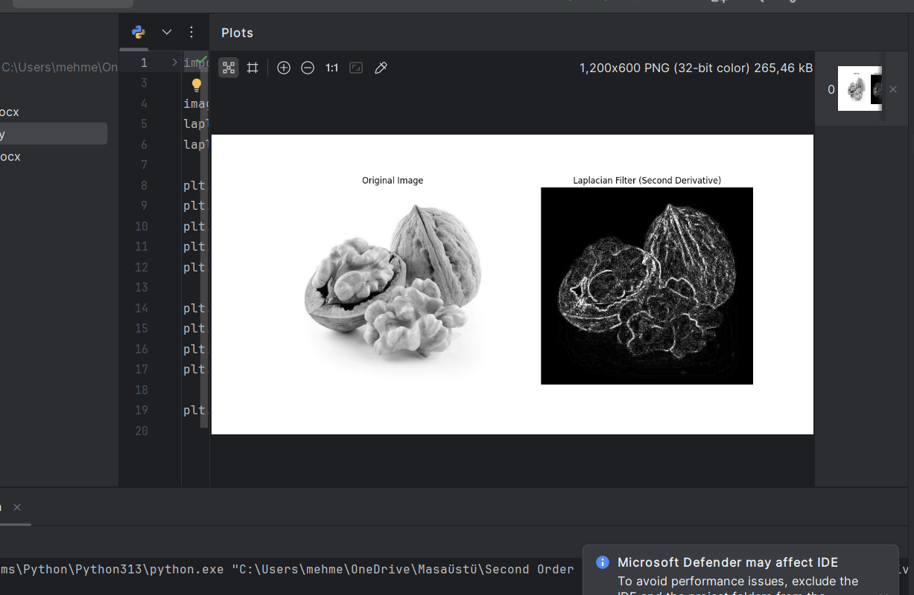
Report
Objective
To apply the Laplacian Filter to the image "cev.jpg" for sharpening and edge enhancement using second-order derivatives.
Methodology
- The Laplacian filter computes the second derivative of pixel intensity values. It identifies regions of rapid intensity change, such as edges and corners.
- A kernel size of 3×33 \times 33×3 was used to capture finer details while minimizing noise amplification.
Results
- Original Image:
  - The grayscale image serves as the input for Laplacian filtering, reducing computational complexity while preserving intensity variations.
- Laplacian Filter (Second Derivative):
  - The Laplacian filter highlighted edges and regions of rapid intensity change. This includes boundaries, fine details, and texture.
  - The second derivative enhances both horizontal and vertical changes simultaneously, providing a more isotropic edge detection compared to directional filters like Sobel.
Advantages
- The Laplacian filter is computationally efficient and isotropic, making it suitable for general edge enhancement.
- It captures finer details compared to first-order derivative methods.
Limitations
- It is sensitive to noise due to the second derivative's amplification of high-frequency components. Pre-smoothing with a Gaussian filter can mitigate this.
Applications
- Image sharpening to enhance details in photographs.
- Feature extraction in object recognition tasks.
- Medical imaging and astronomy for highlighting boundaries and features.

